Database systems weeek2

**Part 1: Retrieving Data with SELECT**

1.1 Retrieving All Expenses:

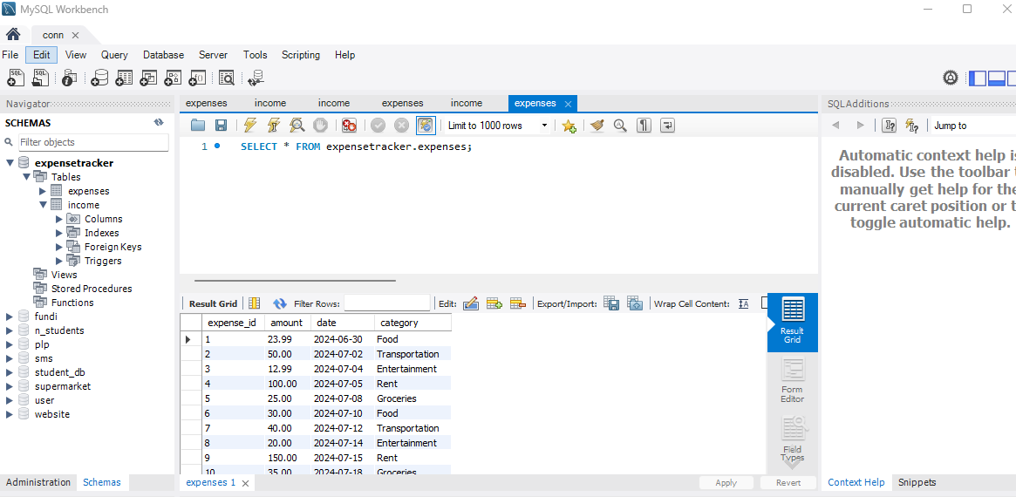

1.2 Specific Columns:

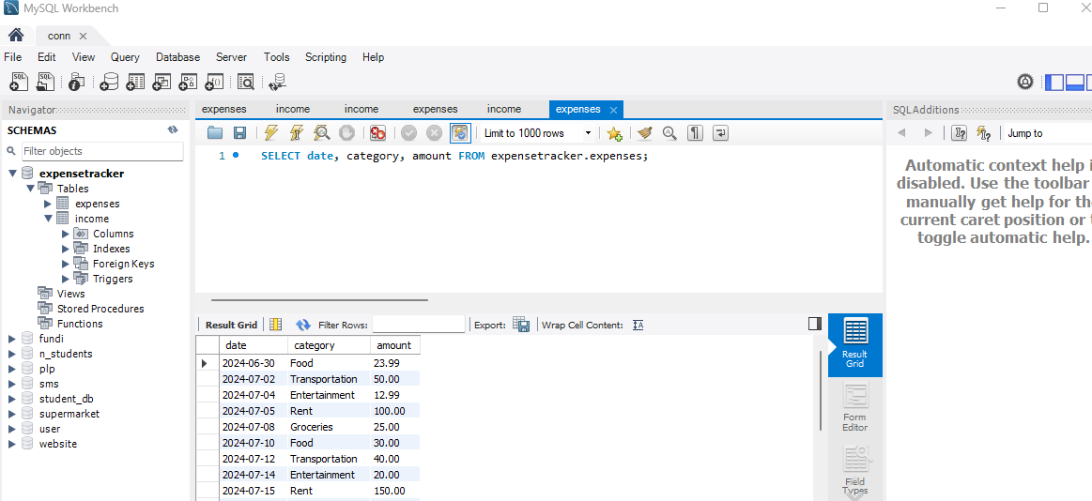

1.3 Filtering by Date Range:

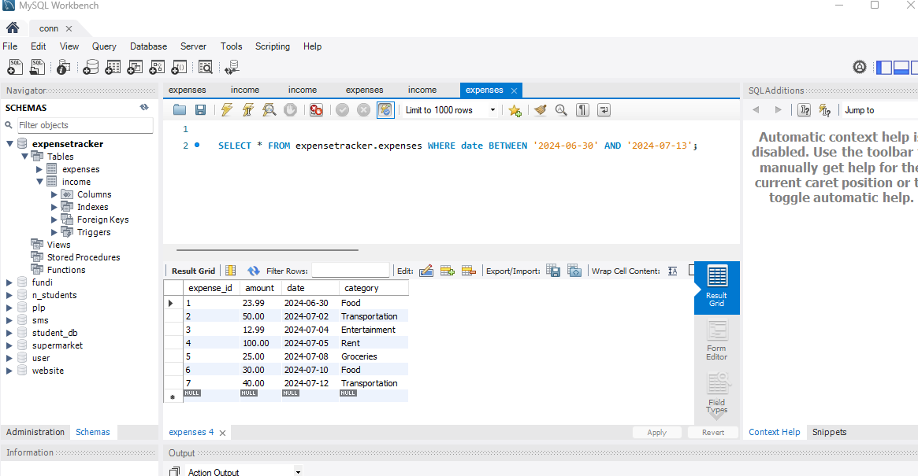

**Part 2: Filtering with WHERE Clause**

2.1 Filtering by Category:

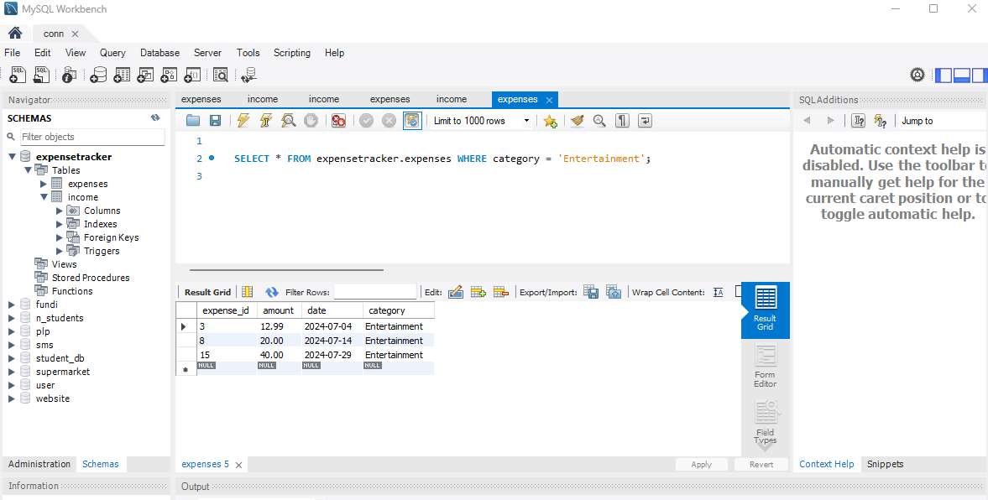

2.2 Filtering with Comparison Operators:

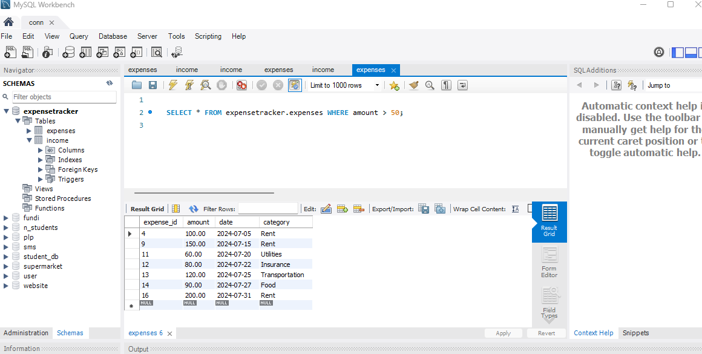

2.3 Combining Filters (AND):

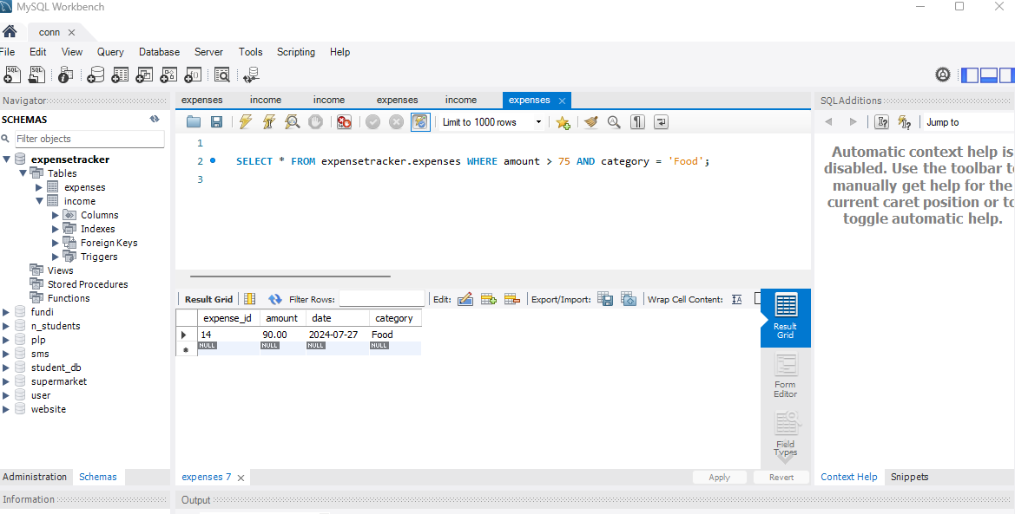

2.4 Combining Filters (OR):

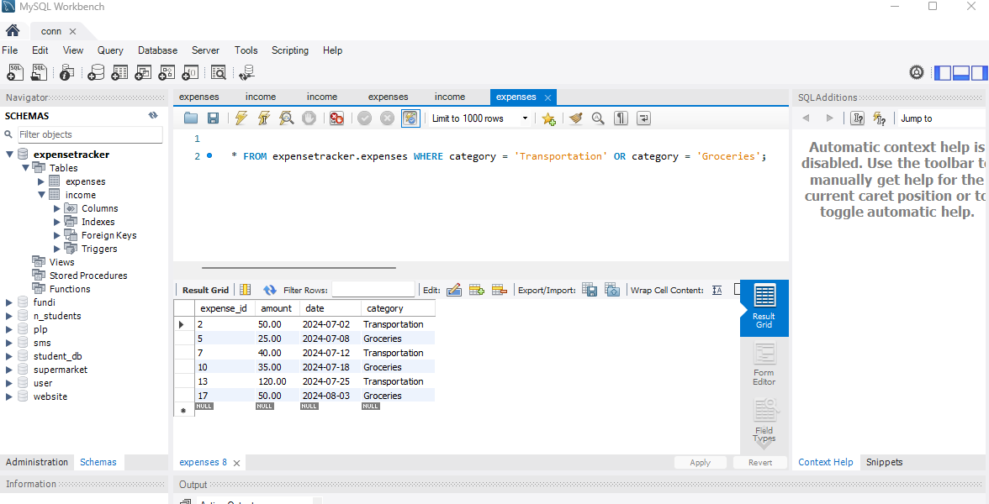

2.5 Filtering with NOT:

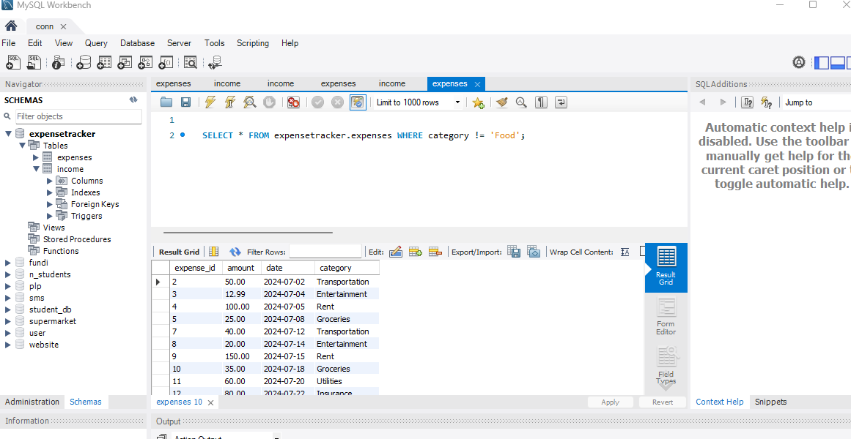

**Part 3: Sorting Retrieved Data**

3.1 Sorting by Amount:

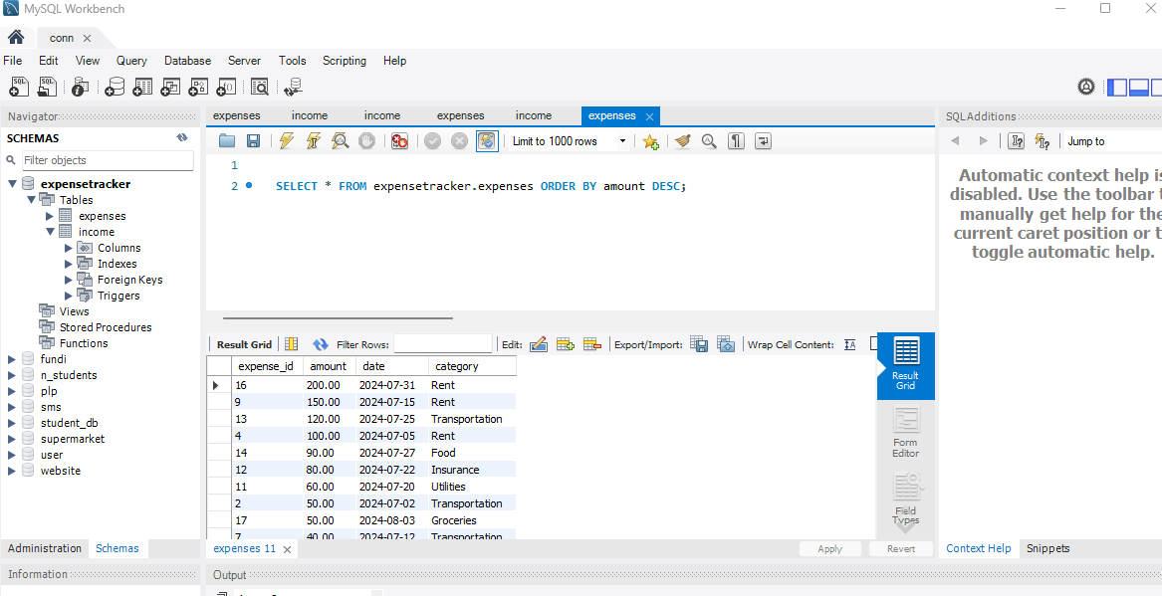

3.2 Sorting by Date and Category:

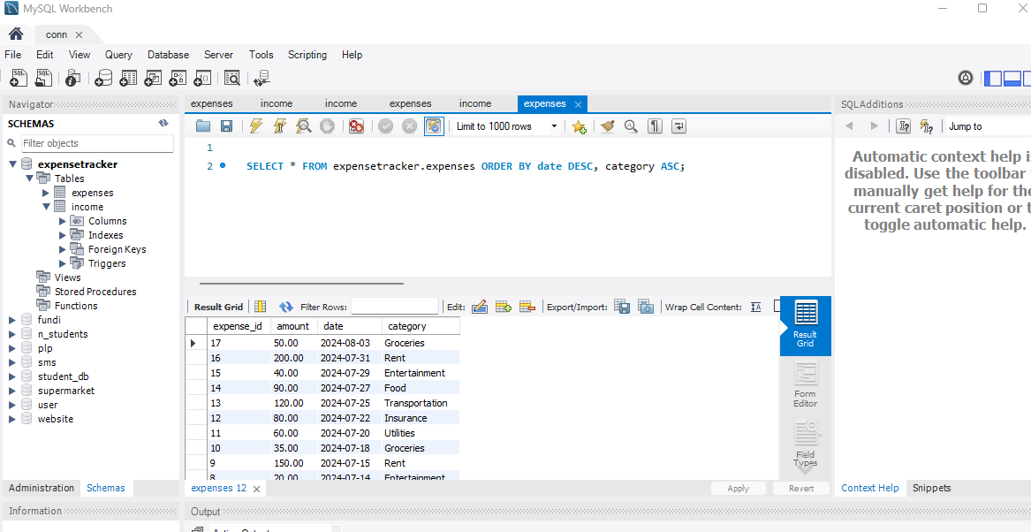

**Part 4: Database Upgrade**

4.1 Creating the "Income" table:

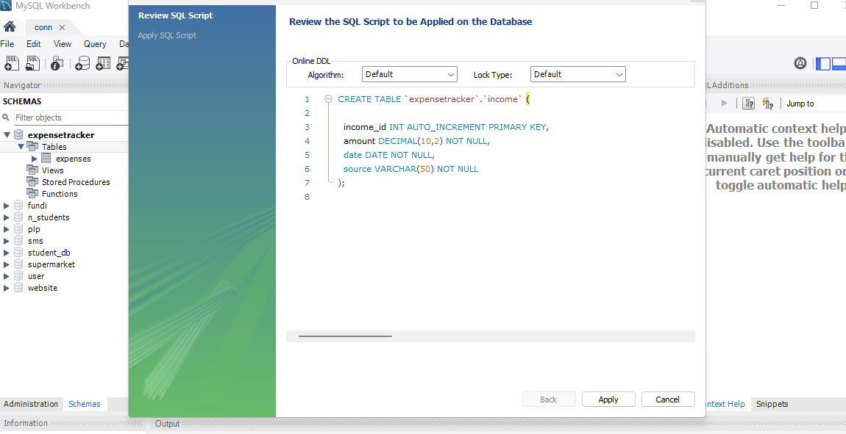

4.2 Adding a new column to the "Income" table:

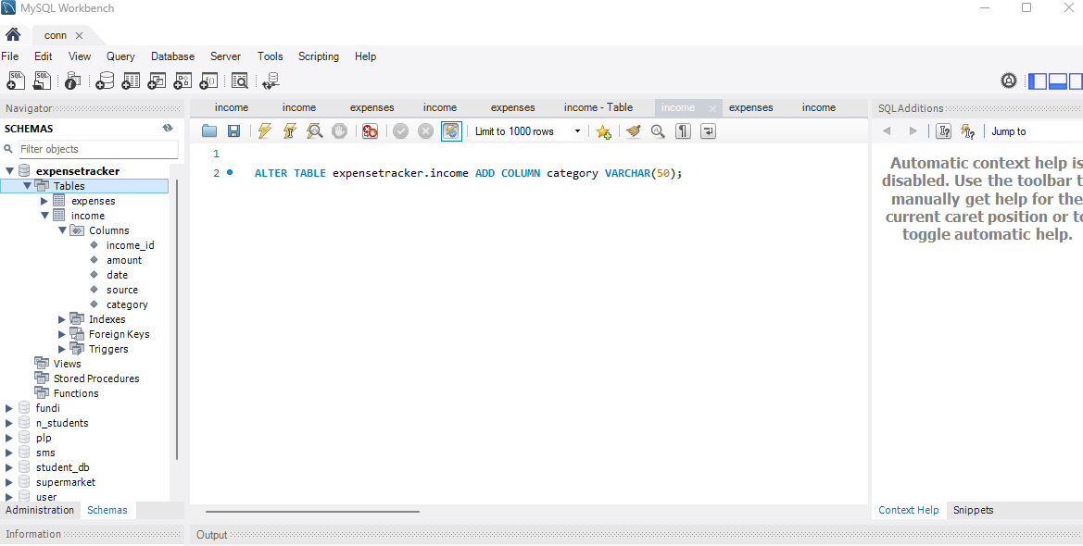

4.3 Removing the "source" column from the "Income" table:

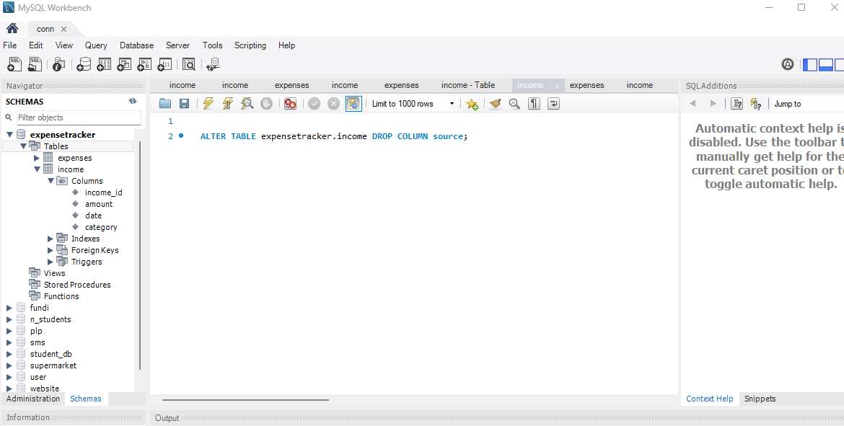

4.4 Dropping the "Income" table:

